Benefits of Moving From CC 6 to CC 7
EnsembleInfra
Impact Assessment (IA)
© 2009 Amdocs
This document contains proprietary and confidential information of Amdocs and shall not be reproduced or transferred to other documents, disclosed to others, or used for any purpose other than that for which it is furnished, without the prior written consent of Amdocs. It shall be returned to the respective Amdocs companies upon request.
The trademark and service marks of Amdocs, including the Amdocs mark and logo, are the exclusive property of Amdocs, and may not be used without permission. All other marks mentioned in this material are the property of their respective owners.
Document Information
Software Version:
Publication Date:
Catalog Number: | document_center\<Doc #xxxxxx> Version0.1
Security Level: | Level 1 - Confidential
Creation Date:
Account/FOP:
Author: | Adi Levi
Editor: | Adi Levi
Last Edit Date:
File Name: | Code Splitter IA
Template:

Contents
1. Introduction 1
1.1 Purpose and Scope 1
1.2 Related Documentation 1
1.3 Terms and Definitions 1
2. Background 2
2.1 The Problem 2
2.2 Proposed Solution 4
2.3 Solution Benefits 5
3. High Level Solution 6
3.1 Solution 6
3.2 Detailed description of steps 10
3.2.1 Prepare helping string lists 10
3.2.2 Invalid source files 11
3.2.3 Unused code sources (c, pc, ppc, cbl, pco) 12
3.2.4 Unused header files (h,rw,raw,ddl,dmv,dmf) 13
3.2.5 Handle Cobol sources 14
3.2.6 Handle C sources 16
3.2.7 Split C Verification 19
3.2.8 Produce X-ref report 20
3.3 Manual changes I - Implement specific ENS improvements 25
3.3.1 Srvgen tool improvement in dl area 25
3.3.2 Static / Issue in US topic performance improvement in dl area 27
3.3.3 Automatic main.list rules 29
3.3.4 cob_gendep.pl performance improvement 30
3.4 Manual changes II - Order in make file rules 31

Introduction

Purpose and Scope
The purpose of this document is to describe the proposed solution for the Code Splitter.
Code Splitter is a tool that splits source files in order to improve performance by significantly reducing memory consumption in Ensemble projects. It also reduces disk space version requirements & storage size, improves build duration time and reduce unnecessary relations to software installations and licenses.
Improved ordered modular and simplified make rules & Apply specific performance improvements to improve maintenance.

Related Documentation

Terms and Definitions

Term | Definition
SMC | Static Memory Consumption (Allocated at run time)
FS | File System (Disk Space)
$suffix | Version name. i.e.: 190
$p | Project name. i.e.: ibg190
$bb | Building block name. i.e.: ibscsm
dl | Data Layer (building block XXXdl)

Background

The Problem
- Often Ensemble code does not comply with proven programming standards and principles such as modular programming
- Many unrelated functions are grouped together in a single source file
- A lot of unused code exists.
- A lot of code duplicate file naming exists.
- A lot of global duplicated variables defined with no extern references.
- A lot of duplicate function naming exists.
- Make file rules are not organized.
- Infra error in build exists on every build (Especially build with clean).
- This results in inflated executables, which leads to
- Poor performance of processes at run time.
- Huge static memory consumption at run time execution.
- Huge disk space requirements on version open.
- Huge disk space is needed for build product storages.
- Long build duration.
- Unnecessary build failures due to unrelated errors.
- Many software installations and licenses are required for many processes on production computers.
- Hard maintenance of make files. Changes are required often due to code changes.
- Since Ensemble code is comprised of thousands of files containing millions of lines of code (and keeps growing), manual changes are not feasible
- “Recently we have had several performance problems at different customer sites which were caused by excessive memory usage … Due to this excessive memory usage … the server CPU's were hardly doing any work on behalf of the application… the excessive memory usage of our processes is still a MAJOR problem”
Ilan Green - Chief Technologies Manager

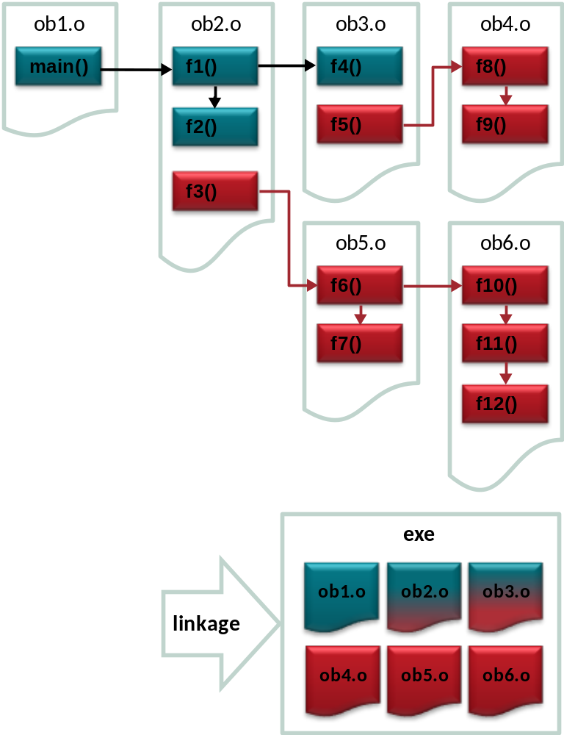
Typical linkage of Ensemble executable before Code Splitter

Proposed Solution
- Code Splitter is a tool that analyzes Ensemble code and automatically splits source files to a more efficient structure.
- Code splitter is fully integrated with software configuration management (XtraC and RCS) - automatic check-out/check-in of files.
- Code splitter creates reports of unused code, public code that should be private and duplicate naming.
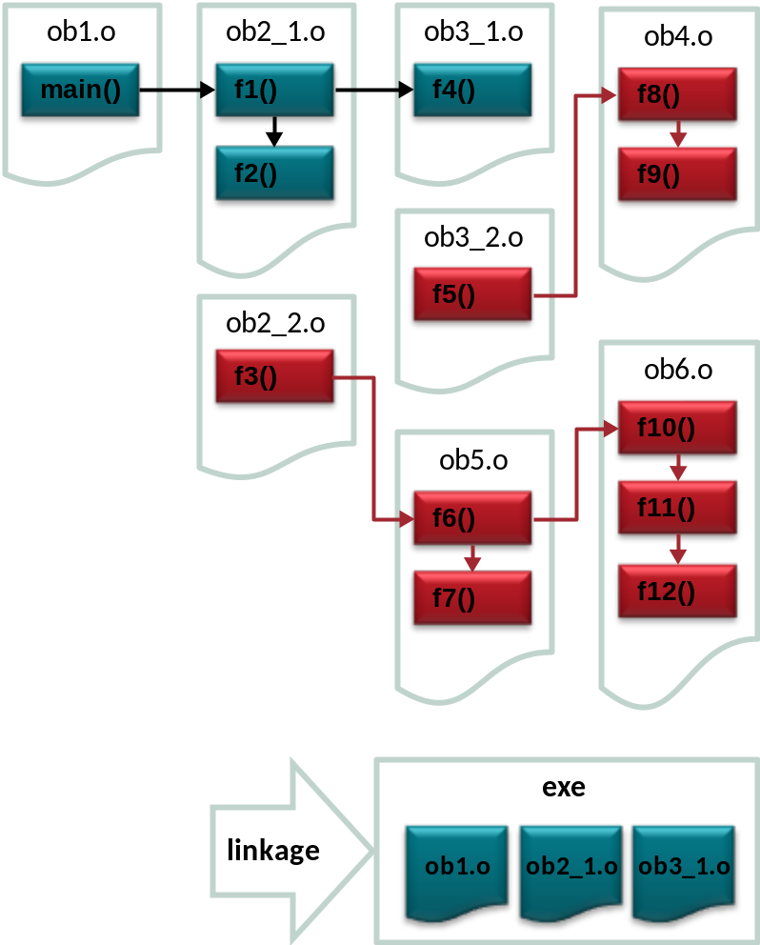
Typical linkage of Ensemble executable after Code Splitter

Solution Benefits
- Improves performance
- In Tuxedo servers and batch processes.
- Reduces TCO
- Reduces hardware (memory and CPU) requirements by reduction (50%-80%) of static memory consumption.
- Reduces disk space for executables by 30%-50%.
- Reduces 3rd party SW license fee due to redundant linkage.
- Improves development efficiency – saves time
- Reduces build duration by 10%-30%.
- Reduces build failures due to unrelated failures (“domino effect”).
- Reduces lock load on file containing many functions.
- Improves OGS maintenance of make file rules
- Reduce the make rules duplication and mess over the version. One shared make file will contain most make rules. Change requirements will be easy for implementation.
- Standard and generalized make rules for supporting special build requirements (C-Advice, Insure, RTC, RTS-debugger etc …) will be easy for implementation.
- Simpler, shorter and direct link commands in build using modular simple formats (Link flags separated from compile flags).
- Added +n flag to all linkage commands. No need to add libraries to link rules after application changes in code.
- Automatic main.list rules. No need to change main.list file after any change (add / delete) of script files (csh, sh, fex etc …).
- Improved compilation performance in dl area (srvgen & us topic improvements).
- Fix all infra errors in build.
- New tools for development use.
- Improved make rules for helping development team compile application changes with structure and data layer changes simply (with no need to move structure /objects/libraries from place to place).
- CSCOPE and Xref reports for development team use and analyzing functions/ variables.
- Tools for working with XtraC tasks and files simply from command line in their local private accounts.

High Level Solution

Solution

- Prepare helping string lists for next steps use
Prepare / collect helping strings that supplies on each global function / variable its definition & reference in the version code (using nm commands on version objects).
- Identify unused sources
Identify invalid files in source area of different cases.
Identify redundant duplicate sources of all kind and file suffixes.
Identify unused main objects included in libraries.
Identify unused code source files (c, ppc, cbl, pco) (sources which all functions it defines are not referenced).
Identify unused header files (h, rw, raw, ddl, dmv, dmf) (views not referenced).
- Handle Cobol sources (cbl, pco)
Remark unreached sections in COBOL sources (Using automatic tool that identifies those sections and remark them).

- Handle C sources (c, pc, ppc)
Split C sources (c, pc, ppc) into independent groups of functions.
Using a smart tool that knows to analyze inter- relations between functions defined in each source taking in account every function / variable relation (function calls, using the same global / static variable...), and an effective algorithm that decides how to split the source functions into new format in a way that only related functions will stay in the same source. (The source is broken into some sources suffixed with names _1, _2,… that together contain all functions in the original source broken.

- Special variable code handling

Identify special cases in code of variables defined in shared include files, causing redundant variable definitions in many sources.
Change those variable definitions to be written in such a way that will be effective and not cause un-necessary variable definition when not needed.
Cases that are found in almost every ENS account:
5.1. In XXXcsm building block:
static pgnsrvperfErr_t srvperfErrBuf;
Move the static variable definition from pgn_debug.h to pgn_debug.c

5.2 In XXXdl building block, there are some topics that contain lock table variable.
./ar/inc/dar_intr.h:static t_ban_k_t dar_lock_ban_key;
./bl/inc/dbl_intr.h:static t_ban_k_t dbl_lock_ban_k;
./cl/inc/dcl_intr.h:static t_ban_k_t dcl_lock_ban_key;
./us/inc/dus_intr.h:static t_acbnlk_k_t dus_lock_accusg_key;
./us/inc/dus_intr.h:static t_acsblk_k_t dus_lock_accusg_sub_key;
./shr/dl_intr.h:static dlsrvcntrl_t dl_srv_control;
Change the definition from static to extern and
Add a new source with no functions that will maintain the global variable. This way, all references to this variable will point to the same global variable, reducing the SMC of all processes.

  - In XXXdl building block, sqlca variable is defined as global variable in each dl source. Change the definition to extern and add a new small source with no functions that will maintain the shared global sqlca variable.

- Implement specific ENS performance build improvements

srvgen tool compilation improvement in dl building block.
Static / issue improvement in dl – topic us (Performance compilation build improvement handling static usage dl sources in one object instead of 12 objects each).
Automatic main.list rules for scripts copied to bin area (Reducing maintenance for main.list sources).
cob_gendep.pl tool performance improvement to dependencies creation.

Clean up of temporary build products during build.
Example: *.ppc produce *.pc, *.c, *.lis to deb area.
Only *.c is needed for debug toos. The *.pc, *.lis are temporary and can be deleted.

- Order in make files to improve maintainance.

Isolate 3’rd party installations in make linkage rules (Use 3’rd party installations only when needed). The code split removes many of the 3’rd party installation redundant relations in CC.

- Unified shared make rules: .product.setup; make.def.version in product level location with new dynamic LINK rules and all other version rules.
Many similar make rules are spread over all make files in CC. An effort is made to share the different rules into one location and reduce the redundant rule definitions.
- Isolate bbs into “o” project dependent only on “b” project (For bbs that “g” project is not dependent on). For example: schapi & opi.
- Remove unused infra topics. (Informix, Forms45, etc …).
- Rules for “-g” / “-s” debug / strip were configured as needed (strip in CC, debug for developers).
- Java rules fixes (& move java sources to dynamic topics).
- Add flag: “-Q +Oprocelim” flag to all linkage commands (Causes additional reduce to SMC in products - working on PA_RISC & Itanium cases).
- Add flag: “-Q +n” flag to all linkage commands to circle the libraries shared in the linkage command to get rid of library duplicated in many linkage commands. Simplifying the so many formats for same linkage command definitions.
- New rule for users to have private “b” lib project in LDDIRS variable when compiling in private accounts.
(Easy the process for users when involving dl changes with application changes).
- Fixed set of rules for linkage and building Tuxedo servers/clients with separated LDFLAGS from COBFLAGS.
- Fixed set of rules for flds / cnt / fml files.
- Isolate 3’rd party installations in make linkage rules.
Use 3’rd party installations only when needed. The code split removes many of the 3’rd party installation redundant relations in CC.
- Fix build infra existing errors.

Those steps needs additional builds (sometimes build with clean) and fix of errors that may be caused as a result from make changes done.

New make rules of the version will be clean and clear
All link definitions and also most of the other rules will be shared in the make.def.version file.

Detailed description of steps

Prepare helping string lists

Purpose
Create list of functions, variables & dependency files used in the version.

Description
Prepare helping strings that supplies in a strict and defined format all global function / variable definition & reference in the version code.
The lists will be used by most of the tools in the next steps in order to deduce on each specific global function / variable all information regarding where it is defined and from where it is referenced.
Flow:
Go in a loop over all building blocks deb area and cnt area in the version and activate nm command on all objects to produce the first 4 relevant output reports.
e.g: Following is a function call relation between 2 objects

~/bb/blcar/v72_0/am/src/aramAdjEnv.cbl
…
CALL "dus_gt_usage"
USING …
~/bb/blcdl/v72_0/us/src/dususage.ppc
…
FUNCSTS_C_T dus_gt_usage ( … )
{ … }

It will be written to the output reports in the following format:
blcdl/dususage.o:dus_gt_usage (list_functions report)
blcar/aramAdjEnv.o:dus_gt_usage (list_calls report)

Invalid source files

Purpose
Identify invalid source files in the version.

Description
Identify invalid file names of different types described below.
Type | Description | e.g.
DUMMY | Junk empty files named: HARVESTDUMMY created by “Create Repository” XtraC process. | gndm/v17_0/cl/inc/HARVESTDUMMY
empty | Empty junk files: other cases. | ibssc/v17_0/snxsai/src/paiC.cpp
product | Products in source area. | ibsup/v17_0/shr/tr_MsgHandler.o
bak_dir | Junk backup directories or source files in wrong location | celltools/v15_0/misc/src/Kobi/newdomF6.fmb
bak_file | Junk backup files | ibsgdd/v17_0/prm/mpupeapst_cre.rql.forcc
invalid_name | Source files with special characters (like space) in name | ibscsm/v17_0/rt/src/arRefund_]PymMode.rt
src | C source files in wrong location | ibsin/v17_0/ep/inc/inep_main.cpp
inc | Include source files in wrong location | ibsmafcom/v17_0/utc/src/pputc_UTIL_pub.h
profile | profile.bb files | ibsrp/v17_0/profile.bb
Flow:
Go over all file names in source area that are checked in to the repository and produce a list of files that match each of the invalid cases described in the table into a 10 different invalid sources reports.
All found cases lists are grouped together and sent via e-mail to the CC team as lists to be checked as suspected to be not in use.

Unused code sources (c, pc, ppc, cbl, pco)

Purpose
Identify unused code source files (c, ppc, cbl, pco).
Identify unused main objects that are included in libraries.

Description
Identify unused code source programs that are suspected to be not referenced from anywhere in the version code.
Reference to object could be made with any of the following ways:
- Function call to any of its global functions.
- Extern variable reference to any of its global variables.
- Using the object as a special case in make files (e.g.: pgn_tux_api32.o).
Flow:
For each object included in lib<bb name>.a:
Get the list of global functions & variables defined in each object using nm command.
In case the function list contains a main function, it will be written to the relevant report.
Look for calls to each of the functions in the list_calls report.
In case no function call was found for any of its functions - its source file name will be written to the report: list_u_source.$p.$bb.
For each source found as unused or with main function symbol it will be mentioned if its name is found in any of the make files in the version.
Example of an unused object that contain 3 functions, none of them is called
hpitan60:mb_ccmtr:~/proj/mtb820/mtrdl > nm -r dpo_sale_chnl_itm_lnk.o | grep 'FUNC |GLOB |0| .text'
[28] | 0| 1312|FUNC |GLOB |0| .text|dpo_sale_chnl_itm_lnk.o:dpo_cl_sale_chnl_itm_link
[27] | 0| 14544|FUNC |GLOB |0| .text|dpo_sale_chnl_itm_lnk.o:dpo_nb_sale_chnl_itm_link
[24] | 0| 3312|FUNC |GLOB |0| .text|dpo_sale_chnl_itm_lnk.o:dpo_st_sale_chnl_itm_link

Unused header files (h,rw,raw,ddl,dmv,dmf)

Purpose

Identify unused header file sources (h, rw, raw, ddl, dmv, dmf).

Description
Identify unused code header files that are suspected to be not in use from anywhere in the version code.
Reference to header files could be made with any of the following ways:
- Header sources or products (e.g.: rw -> h, lb, lr) are referenced in the dependency files.
- Header sources or products (e.g.: rw -> h, lb, lr) are referenced in the *.pco sources with embedded INCLUDE commands (Those cases will not appear in the dependency files).
Flow:
For each candidate header source file look for the source name occurrence (without path and without suffix) in the list_deps report.
In case there is no reference to the name - the header source file name will be written to the output report.

Handle Cobol sources

Purpose

Fix Cobol sources (cbl, pco) – Remark un-used / un-reached sections.

Description
Remark un-used /un-reached sections in Cobol sources (cbl, pco).
Flow:
Copy all COBOL sources in input building block to work area.
For each source activate the following flow:
Remove the remarked lines (“*” at column 7) from the source into temporary file used for the unused section names calculations. ($f1)
Calculate the section names in the source (Using grep commands on reserved COBOL words).
Look for each section name for section names that has no references in the source using the relevant reserved COBOL words (PERFORM, PROCEDURE, GO TO).
Remark the sections that were found as un-used in the fixed source ($f1.step).
Use “grep –n” for calculating the start & end of the section location (line number) in the source. Use awk command to remark that section.
Repeat the process recursively again on the fixed source until there are no more section names to remark.
In case there were no sections to remark, the source is skipped.
Create a list of all sources that had at least one section to remark.

Example for remarked section in a Cobol source
*-------------------------------------------------------------
* Following section was remarked by Code Spliter tool
XXXXXX* YD-END-AC SECTION.
XXXXXX* *-------------------------------------------------------------
XXXXXX* * PURPOSE : Close A&C.
XXXXXX* *-------------------------------------------------------------
XXXXXX* YD-00.
XXXXXX*
XXXXXX* MOVE WS11-AC-ENDPGM-PRM TO AR11-AC-ENDPRM.
XXXXXX*
XXXXXX* SET ACPR-END-PROGRAM IN AR11-AC-ARGS
XXXXXX* TO TRUE.
XXXXXX*
XXXXXX* MOVE "FcEndPgm" TO CTB-ROUTINE-NAME.
XXXXXX*
XXXXXX* PERFORM S-CALL-AC-MAIN.
XXXXXX*
XXXXXX* YD-EXIT.
XXXXXX* EXIT.

Handle C sources

Purpose
Split C code (c, pc, ppc) tool is using nm, awk, sed, grep commands into independent groups of functions.

Description
Split C sources (c, pc, ppc) into independent groups of functions according to the most improved algorithm we have (Also sub functions will be split).
Independent meaning is that there will be no relations defined between any function defined in one group to any of the functions defined in the other groups.
Relation between 2 global functions in the same source can be defined with any of the following ways:
- Function call (One of them is calling the other function).
- They both use (share) the same global / static variable.
- They both use (share) the same private function.
Results of a successful run:
- split_report - A report that contains all important information and details including issues encountered during the process flow.
- For each split source: Broken C sources numbered by group number running number (1 … n).
e.g.: pgn_datetime.c ( 16 3 1 )
-rw-r--r-- 1 mb_ccnmx cctlg 0 Mar 23 12:26 pgn_datetime.c
-rw-r--r-- 1 mb_ccnmx cctlg 1264 Mar 23 12:26 pgn_datetime_1.c
-rw-r--r-- 1 mb_ccnmx cctlg 40974 Mar 23 12:26 pgn_datetime_2.c
-rw-r--r-- 1 mb_ccnmx cctlg 9393 Mar 23 12:26 pgn_datetime_3.c

Flow:
Copy all C sources from the list list_func_used.$p.$bb created in previous reports into the work area.
The flow for working on each C source:
  - The line numbers of each function (including static functions) in the source is determined.
  - All source remarks and strings in the source are temporary removed without changing line locations (for the purpose of analyzing).
  - Source is broken into header (F0) and numbered sub-sources, each containing one function. (F0;F1-FN).
  - An NxN A-symmetric relation table is generated with all function/variable relations between source functions.
Each function call from Fi -> Fj is transmitted into i -> j relation.
All relations are defined while analyzing the source function calls, variables (global, static) and their use, static functions etc…
  - Create a functional-related group of functions.
The functions are scanned over all entries from the top to the bottom, starting with the internal functions.
It stops in the first global function (Fi) that is called from list_calls report (Contract calls from cnt objects are ignored at that point).
Than it scan the table and collects the minimum group of functions that are related to the function Fi (That function Fi needs).
This way first group is created.
All functions in the group created are marked as “already selected” in the list of functions (including Fi).
  - Step 5 is repeated until there are no more used global functions found.
  - The rest of the functions not marked yet are grouped into additional group.
This last group is usually all functions in the source that are not in use.
That group will be found to be not in use in the next unused C sources scan.
Note: Additional group will be created with all functions that are called only from contract files (cnt/…_32c.o objects).
  - The source is copied back with the remarks and strings and broken again to its functions like in step 2, but now we are after the analyze and we have decided which are the functions that contribute each group.
In this step if only one group was decided, the C source is skipped because it cannot be split.
Note: For dl sources this is not the end of the story here because in this type of sources variables are moved from global -> static and from static -> local according to the context.
  - A specific header is created for each group; minimized from variables / arrays / defines and function prototypes that are not used (needed) in this group.
A source remark is created for each group.
The include lines remains the same as in original header.
Note: For dl sources additional handling is done on variables in order to reduce SMC. i.e.: PC variables defined in the header and in use only in one function are moved from the header to the function to be local variables. SCOPE definition is validated to be static for header variables only.
  - Each group of functions is re-created into a new numbered source by concatenation of the header with the broken functions that belong to the group producing a new numbered source.

Split C Verification
Report on duplicated global functions / variables found in split C sources.
Perform additional validation checks.

Purpose

Validation report on split process that will run after the split code was checked in to CC and all build issues are solved.

Description
Results of a successful run:
- verify_dup_function - A list of functions that are duplicated among the split C sources. Each duplicated function with its occurrence in split objects.
- verify_dup_variable - A list of variables that are duplicated among the split C sources. Each duplicated variable with its occurrence in split objects.
- verify_objects_dl – A list of *.c temporary products of split *.ppc code that contain un-parsed PC definitions (like: ACTCD_PC_VALUES_CHANGE_CYCLE). This code should have been parsed to their values in that stage and may cause run time errors.
Flow:
Simple use of files list_functions & list_variables files using grep, uniq and sort commands.

Merge tool for developers
A tool that helps in merging changes in previous version on C code that was split in current version.
The tool converts the source in previous version into the split format used in current version. It helps the developers to check in merge changes to the version where Code Split was implemented in an easy and simple way.
Merged code need to be checked in the new split format used in the version.

Description
This example is from BellConso account after implementing “Code Split” on v919 version which is based on v918 version.

You need to be located where the file resists in your private account with the updated source in v918. Also you need to be in set_prod to v918 version

Following is a detailed example for using this tool.

- Work on a source that was split in the new version

The source dar_adj_ol.ppc has been changed in v918 version and is located in your private account (modified source)
This source is deleted in v919 because it was split into sources: dar_adj_ol.ppc …

hpp422!mb_ccblx:~/bb/blcdl/v91_9/ar/src [218]> ll dar_adj_ol*
-r--r--r-- 1 mb_ccblx cctlg 9786 Jul 24 15:33 dar_adj_ol.ppc.cos
-r--r--r-- 1 mb_ccblx cctlg 24154 Jul 24 15:33 dar_adj_ol_1.ppc
-r--r--r-- 1 mb_ccblx cctlg 7537 Jul 24 15:33 dar_adj_ol_10.ppc
-r--r--r-- 1 mb_ccblx cctlg 9547 Jul 24 15:33 dar_adj_ol_2.ppc
-r--r--r-- 1 mb_ccblx cctlg 9925 Jul 24 15:33 dar_adj_ol_3.ppc
-r--r--r-- 1 mb_ccblx cctlg 9500 Jul 24 15:33 dar_adj_ol_4.ppc
-r--r--r-- 1 mb_ccblx cctlg 9830 Jul 24 15:33 dar_adj_ol_5.ppc
-r--r--r-- 1 mb_ccblx cctlg 5170 Jul 24 15:33 dar_adj_ol_6.ppc
-r--r--r-- 1 mb_ccblx cctlg 23761 Jul 24 15:33 dar_adj_ol_7.ppc
-r--r--r-- 1 mb_ccblx cctlg 5437 Jul 24 15:33 dar_adj_ol_8.ppc
-r--r--r-- 1 mb_ccblx cctlg 95345 Jul 24 15:33 dar_adj_ol_9.ppc

In order to convert it to the new split format as in v919 version, you simply activate the following and get the converted sources.

hpp422!yaeln:~/bb/blcdl/v91_8/ar/src > Split_C_code dar_adj_ol.ppc

dar_adj_ol.ppc ( 7 4 2 1 1 1 1 1 1 1 ) ← The output from the merge tool

dar_adj_ol_1.ppc
dar_adj_ol_9.ppc

New sources are under: /blcuser4/blc/infra/yaeln/CodeSplit/work.blb918.blcdl

This process has converted your source into the format used in v919 (split sources)
At the output location we find the split files that are produced from the source we activated on.
The tool also compares between the 2 groups of sources and tells us which sources had a change in v919

Explanation on the output:

hpp422!yaeln:~/CodeSplit/work.blb918.blcdl [247]> ll *
-rw-r--r-- 1 yaeln infra 24156 Aug 23 17:54 dar_adj_ol_1.ppc ← Sources broken from the modified source
-rw-r--r-- 1 yaeln infra 7537 Aug 23 17:54 dar_adj_ol_10.ppc
-rw-r--r-- 1 yaeln infra 9547 Aug 23 17:54 dar_adj_ol_2.ppc
-rw-r--r-- 1 yaeln infra 9925 Aug 23 17:54 dar_adj_ol_3.ppc
-rw-r--r-- 1 yaeln infra 9500 Aug 23 17:54 dar_adj_ol_4.ppc
-rw-r--r-- 1 yaeln infra 9830 Aug 23 17:54 dar_adj_ol_5.ppc
-rw-r--r-- 1 yaeln infra 5170 Aug 23 17:54 dar_adj_ol_6.ppc
-rw-r--r-- 1 yaeln infra 23761 Aug 23 17:54 dar_adj_ol_7.ppc
-rw-r--r-- 1 yaeln infra 5437 Aug 23 17:54 dar_adj_ol_8.ppc
-rw-r--r-- 1 yaeln infra 95356 Aug 23 17:54 dar_adj_ol_9.ppc

v91_9:
total 404
-r--r--r-- 1 yaeln infra 24154 Aug 23 17:54 dar_adj_ol_1.ppc ← Copy of the sources in CC in v919
-r--r--r-- 1 yaeln infra 7537 Aug 23 17:54 dar_adj_ol_10.ppc
-r--r--r-- 1 yaeln infra 9547 Aug 23 17:54 dar_adj_ol_2.ppc
-r--r--r-- 1 yaeln infra 9925 Aug 23 17:54 dar_adj_ol_3.ppc
-r--r--r-- 1 yaeln infra 9500 Aug 23 17:54 dar_adj_ol_4.ppc
-r--r--r-- 1 yaeln infra 9830 Aug 23 17:54 dar_adj_ol_5.ppc
-r--r--r-- 1 yaeln infra 5170 Aug 23 17:54 dar_adj_ol_6.ppc
-r--r--r-- 1 yaeln infra 23761 Aug 23 17:54 dar_adj_ol_7.ppc
-r--r--r-- 1 yaeln infra 5437 Aug 23 17:54 dar_adj_ol_8.ppc
-r--r--r-- 1 yaeln infra 95345 Aug 23 17:54 dar_adj_ol_9.ppc

And the differences are in sources 1, 9 in v919 version simply by comparing the 2 sets of broken sources

hpp422!yaeln:~/CodeSplit/work.blb918.blcdl [249]> diff v91_9/ . | grep diff
diff v91_9//dar_adj_ol_1.ppc ./dar_adj_ol_1.ppc
diff v91_9//dar_adj_ol_9.ppc ./dar_adj_ol_9.ppc

What left to be done now?
Create a task in v919 and update sources: dar_adj_ol_1.ppc, dar_adj_ol_9.ppc with the updated sources under: ~/CodeSplit/work.blb918.blcdl

Produce X-ref report

Purpose
Identify / analyzing all function calls between objects in the version in a clear report.
Identify objects which are used / called only from one main object or tuxedo server contract.

Description
Identify all function call relations between objects in the version. The report will be used as an analysis made on each object function use for phase 2 steps purposes.
Results of a successful run:
- list_search.$p.$bb - A report with an ordered list of each object in the bb library and its analysis for each function in it and its use (The name of objects that call it in the version).
- List_objects.$p.$bb – A report that identify objects which are used / called only from one main object or tuxedo server contract.
Those are candidates to be added to main.list / make.bin rules in order to reduce library which is a shared area (exposed) in linkage commands.
Example: Object analysis
==================================================
27. [3] par_ban_3.o:arInCstBan
blccsm/pcs_futsub_13.o
lib blccsm/pgn_autoload_utils_2_2.o
cnt cnt/par_ban_c32_s.o
28. [3] par_ban_3.o:pcs_move_olnrec_to_dlrec
lib blccsm/par_ban_4.o
==================================================

What do we understand from it ?
The object: par_ban_3.o contains 3 functions (See: [3]).
Only 2 of them are referenced from other objects.
Their names are: arInCstBan, pcs_move_olnrec_to_dlrec.
For each function we see the objects that call to that function.
The lib prefix is added in case that the calling object exists in a library.

Flow:
For each object included in lib<bb name>.a:
Go over all global functions in it and deduce the function calls to it from the list_calls report. Write each item of them to the report in the requested format. For each item check if calling object is defined in its bb library.
The report will be numbered and each object analyses will be separated.
The objects that are not called from any object included in libraries are written to the list_objects.$p.$bb report.

Manual changes I - Implement specific ENS improvements

Req. ID | Phase | Description of functional requirement
MC-1 |  | Implement specific ENS improvements.
MC.1.a | 1 | Srvgen tool improvement in dl.
MC.1.b | 1 | Static/issue improvement in dl – topic us.
MC.1.c | 1 | Automatic main.list rules for scripts copied to bin area.
MC.1.d | 1 | Cob_gendep.pl performance improvement.

Srvgen tool improvement in dl area

Implement changes in source area and CC tools in order to get additional performance improvements in the daily builds and for compilations in private accounts.

Description of the problem
The srvgen is a tool that is responsible for creating topic contract files named dXX_srv.h under XXXdl building block. It re-creates the contract file of each topic with prototypes of all functions in that topic whenever any file has changed in the topic.

The dXX_srv.h file is a trigger to compile whole topic sources again, because all topic sources are doing include to it.

For example, if a change is made in ~/bb/ibsdl/v19_0/cs/src/dcs_subscr.ppc file, the srvgen is activated on the topic cs (srvgen cs) in the next build.
If this change did not affect the contracts of the functions, which is the case in many of the code changes, then because the contract timestamp was updated (dcs_srv.h), all topic files will be re-compiled, because they all use include to this contract.

Meaning any small change in a source in topic cs causes all topic files to be re-compiled in the daily CC build

Script fix details
Name: srvgen.c, srvgen.csh
Location: celltools/v15_0/srvg/src

Solution
- srvgen.c
Reduce warnings in compilation.
Remark the section that writes the function remark to the dXX_srv.h contract file
Motivation: Reduce the number of “Found comment inside comment” warnings in build compilation.

- srvgen.csh
The srvgen logic will stay with same, but produce the contract into temporary file named: dXX_srv.h.last that will be compared to the dXX_srv.h
Only in case that the temporary file is different, the dXX_srv.h will be overridden and its timestamp will be updated, causing the topic sources to be re-compiled. This way, we will save the whole topic compilation when some source is changed with no change affect to the contract.

- XXXdl make files
Will be configured accordingly.
All make.def files under XX/inc will be deleted.
The srvgen rules will be defined only in XXXdl/shr/make.def.
That make.def duplication of rules is redundant and causes the srvgen to run twice on same topics many times in the existing build logs.

Static / Issue in US topic performance improvement in dl area

Implement changes in source area and CC tools in order to get additional performance improvements in the daily builds and for compilations in private accounts.

Description of the problem
The topic US in XXXdl building block is a dynamic topic.
Some of the sources in this topic are written in couples.
i.e.: dususgcpbcu.ppc, dususgcpbcu_issue.ppc
The dususgcpbcu.ppc contains dynamic functions that one of their parameter is the USAGE / ACCUMULATED_USAGE table name usually named: issue_code.
The input issue_code value is checked at run time and if the name is USST01, USST02,…,USST12 or AUST01,AUST02,…,AUST12 than the static function that is written in dususgcpbcu_issue.ppc is activated. This source defines one function that is generated into 12 functions for the 12 cycles.

The problem is that the make rules creating 12 objects from dususgcpbcu_issue.ppc source are very heavy and takes lot of time to process. US topic compilation takes around 1 hour to compile fully.
XXXdl/vXX_0/Us/src/make.def rules are complicated and heavy.

Script fix details
Name: pre_us; All files named: dus…_isse.ppc
Location: celltools/v15_0/srvg/src; XXXdl/v72_0/us/src

Solution

A new mechanism will produce a source with all 12 static duplications in the same source that will be compiled as a regular *.ppc file.

All dus_..._issue.ppc files will be replaced to dus_..._issue
Each such source will be added a line remarked before the first function.
/* START OF STATIC TEMPLATE FUNCTIONS */
This sign will be used by a new tool (pre_us) to separate between the header and the functions in the template source.
All make rules in US topic will be removed.
New simple script (pre_us) will be added in celltools bb that can produce the 12 needed static functions from the dus…_issue template file into dus…_static.ppc source (not checked in to XtraC).
It will be activated with the srvgen of the topic.

dus_srv.h.last: $(us_srcs)
$(CCMPA)/bin/pre_us
srvgen us $(SRV_MODE)

After change implemented in this topic, the whole topic will be fully re-compiled in some minutes (5-10 minutes).

Automatic main.list rules
Implement this change can save lot of OGS changes that need to be done by application / Infra teams with any change in scripts done in any topic all over main.list files in source area.

Description of the problem
Whenever there is a new script (*.csh, *.fex etc…) added by application, there is a need to add the target name to the main.list file in the topic where the script is located.

This is an overhead on application teams and on CC team when the topic is under Infra bb (Many times there are requests for such changes from Integration team).

Script fix details
Name: make.def in product level
Location: product area (e.g.: ~/product/CONSO/v720/config)

Solution

A new rule will replace all main.list rules for copying scripts of different type to the bin area (*.fex, *.sh,..).
The rule is calculating at BIN phase the name of the scripts in each topic
It adds them to the target list to BINS variable.
This will cause the rule to be activated automatically.

#-----------------------
# main.list replacement rules for BIN phase scripts
#-----------------------

ifeq ($(BIN_PHASE),YES)
FEX_FILES := $(shell ls $(CCWSCA)/$(TOPIC)/src/*.fex 2> /dev/null | sed 's/^.*\///g' )
SQL_FILES := $(shell ls $(CCWSCA)/$(TOPIC)/src/*.sql 2> /dev/null | sed 's/^.*\///g' )
CTL_FILES := $(shell ls $(CCWSCA)/$(TOPIC)/src/*.ctl 2> /dev/null | sed 's/^.*\///g' )
BINS += $(FEX_FILES) $(SQL_FILES) $(CTL_FILES)
SH_FILES := $(shell ls $(CCWSCA)/$(TOPIC)/src/*.sh 2> /dev/null | sed 's/^.*\///g' | sed 's/\.sh//' )
CSH_FILES := $(shell ls $(CCWSCA)/$(TOPIC)/src/*.csh 2> /dev/null | sed 's/^.*\///g' | sed 's/\.csh//' )
KSH_FILES := $(shell ls $(CCWSCA)/$(TOPIC)/src/*.ksh 2> /dev/null | sed 's/^.*\///g' | sed 's/\.ksh//' )
PL_FILES := $(shell ls $(CCWSCA)/$(TOPIC)/src/*.pl 2> /dev/null | sed 's/^.*\///g' | sed 's/\.pl//' )
BINS += $(SH_FILES) $(CSH_FILES) $(KSH_FILES) $(PL_FILES)
endif

Instead of writing each script name in the main.list, it is only needed to add the target names to the BINS variable.This is exactly what this new make rule is doing.

cob_gendep.pl performance improvement

Implement changes in source area and CC tools in order to get additional performance improvements in the daily builds and for compilations in private accounts.

Description of the problem
This script is responsible on creating dependency files for Cobol source files (*.cbl, *.pco and so on).

In conversion bb (Sprint - nxtcb) there were many complicated Cobol sources that made the build for this bb be endless (6-10 hours to compile all bb with clean).
After deep re-search of the points where the build was stack, a simple small change in the cob_depgen.pl script caused build time to reduce to 15 minutes.

Script fix details
Name: cob_depgen.pl
Location: $HARCCHOME/bin

Solution

Change is inside the loop that goes over all include files context lines.
It is looking for COPY commands to be added to the dependency file.
The change is that in case line contains 88 or VALUE, loop is skiped.
A performance improvement is achieved, because include files sometimes contain so many 88 values (i.e.: actcd.va).

The “if” condition that was added inside the loop:

open($file,$file);
while ( <$file> ) {
$line = $_;

# skip over many non relevant lines lines
if ( $line =~ /\s+88 / || $line =~ /VALUE / || $line =~ /,\"/ ) {
#print "$line\n";
next;
}

Manual changes II - Order in make file rules

Req. ID | Phase | Description of functional requirement
MC -1 |  | Order in make files.
MC.1.a | 1 | Unified shared make rules. Improved and ordered make rules.  Fixed set of rules for linkage and building Tuxedo servers/clients.  Rules for java code.  Fixed set of rules for flds / cnt / fml files.  Rules for “-g” / “-s” debug / strip …
MC.1.b | 1 | Isolate infra bb’s to be independent version.  Fix build infra existing errors.
MC.1.c | 1 | Isolate bb’s into a new “o” project dependent only on “b” project.
MC.1.d | 1 | Isolate 3’rd party installations in make linkage rules.

- Unified shared make rules: .product.setup; make.def.version in product level location with new dynamic LINK rules and all other version rules.
- Isolate bbs into “o” project dependent only on “b” project (For bbs that “g” project is not dependent on). For example: schapi & opi.
- Remove unused infra topics. (Informix, Forms45, etc …).
- Rules for “-g” / “-s” debug / strip were configured as needed (strip in CC, debug for developers).
- Java rules fixes (& move java sources to dynamic topics).
- Add flag: “-Q +Oprocelim” flag to all linkage commands (Causes additional reduce to SMC in products - working on PA_RISC & Itanium cases).
- Fixed set of rules for linkage and building Tuxedo servers/clients with separated LDFLAGS from COBFLAGS.
- Fixed set of rules for flds / cnt / fml files.
- Isolate 3’rd party installations in make linkage rules.
- Fix build infra existing errors. (Was mentioned before).

Those steps needs additional builds (sometimes build with clean) and fix of errors that may be caused as a result from make changes done.

New make rules of the version will be clean and clear
All link definitions and also most of the other rules will be shared in the make.def.version file.

Document Release Information

Soft-ware Version | Editor | Edited Date | Comments | Sent to site | Approved By | Doc Ver.

